BISMA BILAL
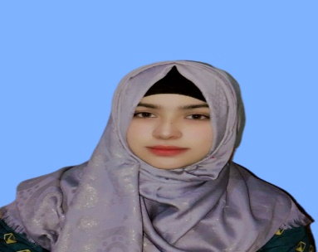  PERSONAL DETAILS:  PERSONAL DATA:  Father’s Name : M .Bilal  Date of Birth :18-09-2004  NIC # : 32102-2477401-2  Gender : Female  Domicile : Dera Ghazi Khan (Punjab)  Nationality :Pakistan  EMAIL: bismabilal189@gmail.com  MOBILE: +92-3171669876  CURRENT ADDRESS:  Basti Bangla Lashari. Tunsa Road Dera Ghazi Khan.  INTERESTS:  - Teaching  - Social work  - Banking and Financial services  LANGUAGES KNOWN:  - English, Urdu, Saraiki,Punjabi  (writing, reading, speaking)  REFERENCE:  Will be Furnished on demand | CAREER OBJECTIVE:  Seeking a career with a career-oriented organization; that can provide me the platform for becoming a well-recognized professional and ultimately attaining prestige and pride for the organization and for myself as well.  ACADEMICS  - BS IT( 2021-2025)  Ghazi University , DG Khan  - Intermediate (Computer sciences) 2021  Board of Intermediate & Secondary Education DG Khan.  - Matric (Science) 2019  Board of Intermediate & Secondary Education DG Khan.  Skills  - E-ROZGAR (Technical)  - Computer Operator  - Communication Skills  - Ms Word and Excel

